Experiment 9: CFT (Exploitation and Privilege Escalation)

Aim: To demonstrate ethical hacking for a vulnerable machine using various tools.

Learning Outcomes:
After completion of this experiment, student should be able to

- Use various tools like netdiscover, Metasploit framework, nmap, dirb etc.
- Implement ethical hacking methodology
- Compromise vulnerable machine
Theory:
Figure 1 below indicates basic steps involved in hacking.

Scanning
Gaining Access
Tracks
Figure 1: Basic Hacking Process

Some of the tools that you are may use in this lab are Network Scanning
  - netdiscover
  - nmap Enumeration
  - dirb
  - fcrackzip Exploitation
  - Metasploit
  - /etc/shadow
  - john Privilege Escalation
  - ssh
  - python library hijacking
  - root flag

Reference: https://www.hackingarticles.in/corrosion-2-vulnhub-walkthrough/

Exploitation

Now that we have the credentials, we can begin exploiting them using a Metasploit. In these instances, employing a Tomcat exploit is the best option. Then give us all the information we need to use it, and we’re ready to go.

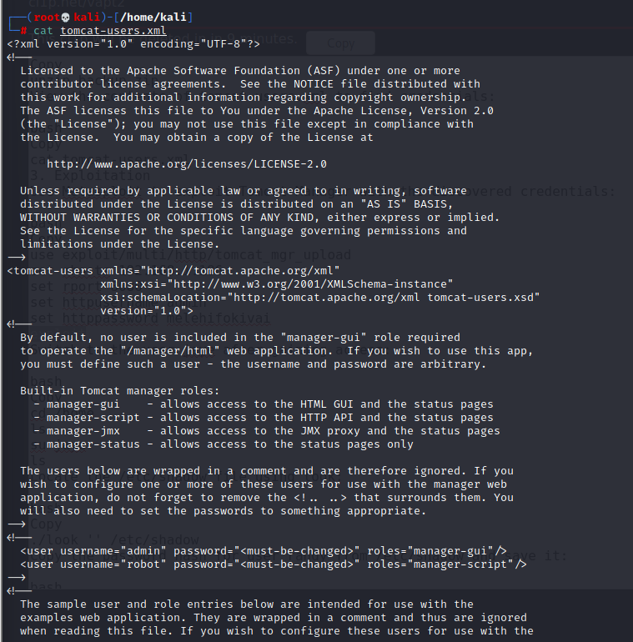

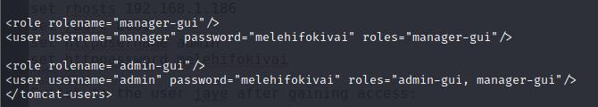

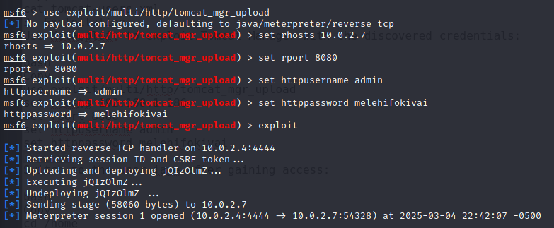
Then give us all the information we need to use it, and we’re ready to go. As you can see, we had a meterpreter session.
We just switched the directory to home. We discover that we have two users in this lab, Jaye and Randy. We switched to user Jaye. It has the same password (melehifokivai) that we found out earlier.

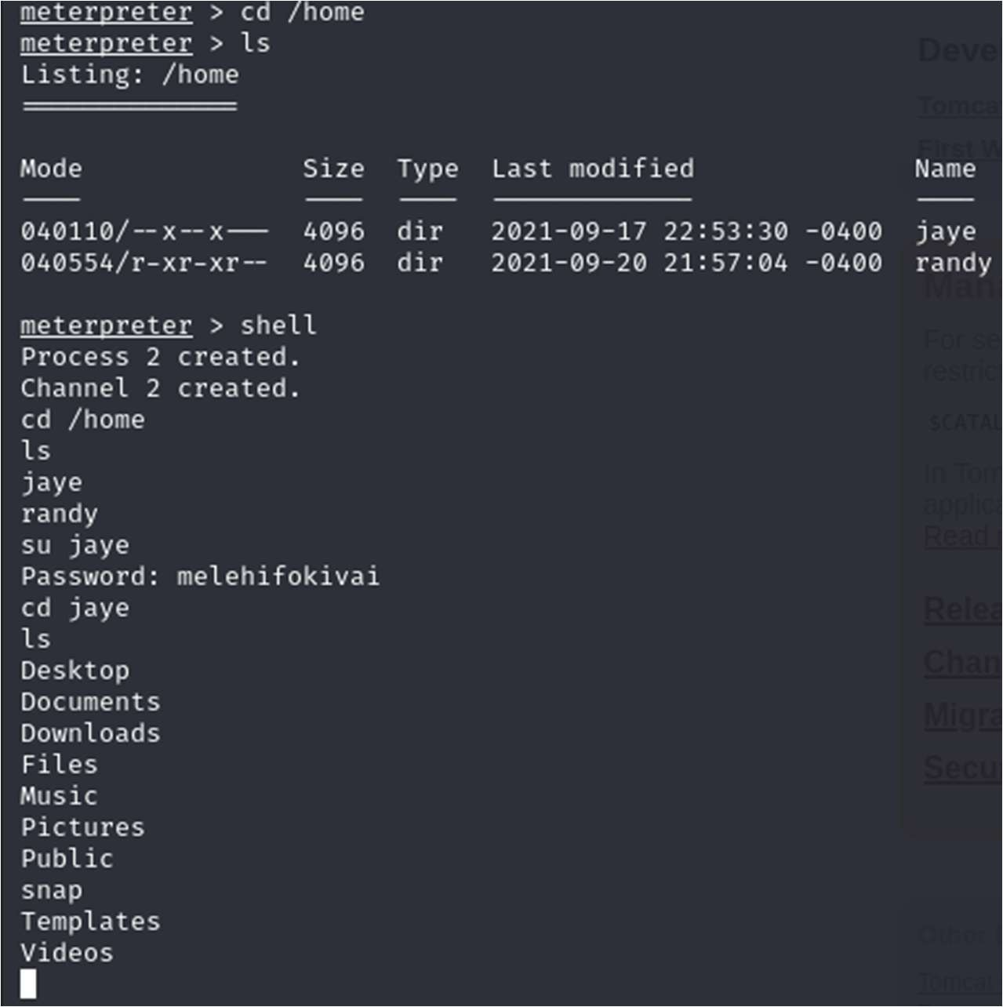

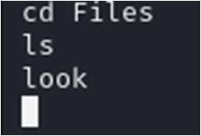

We discovered that this individual has a look called the .program that allows us to locate any file.
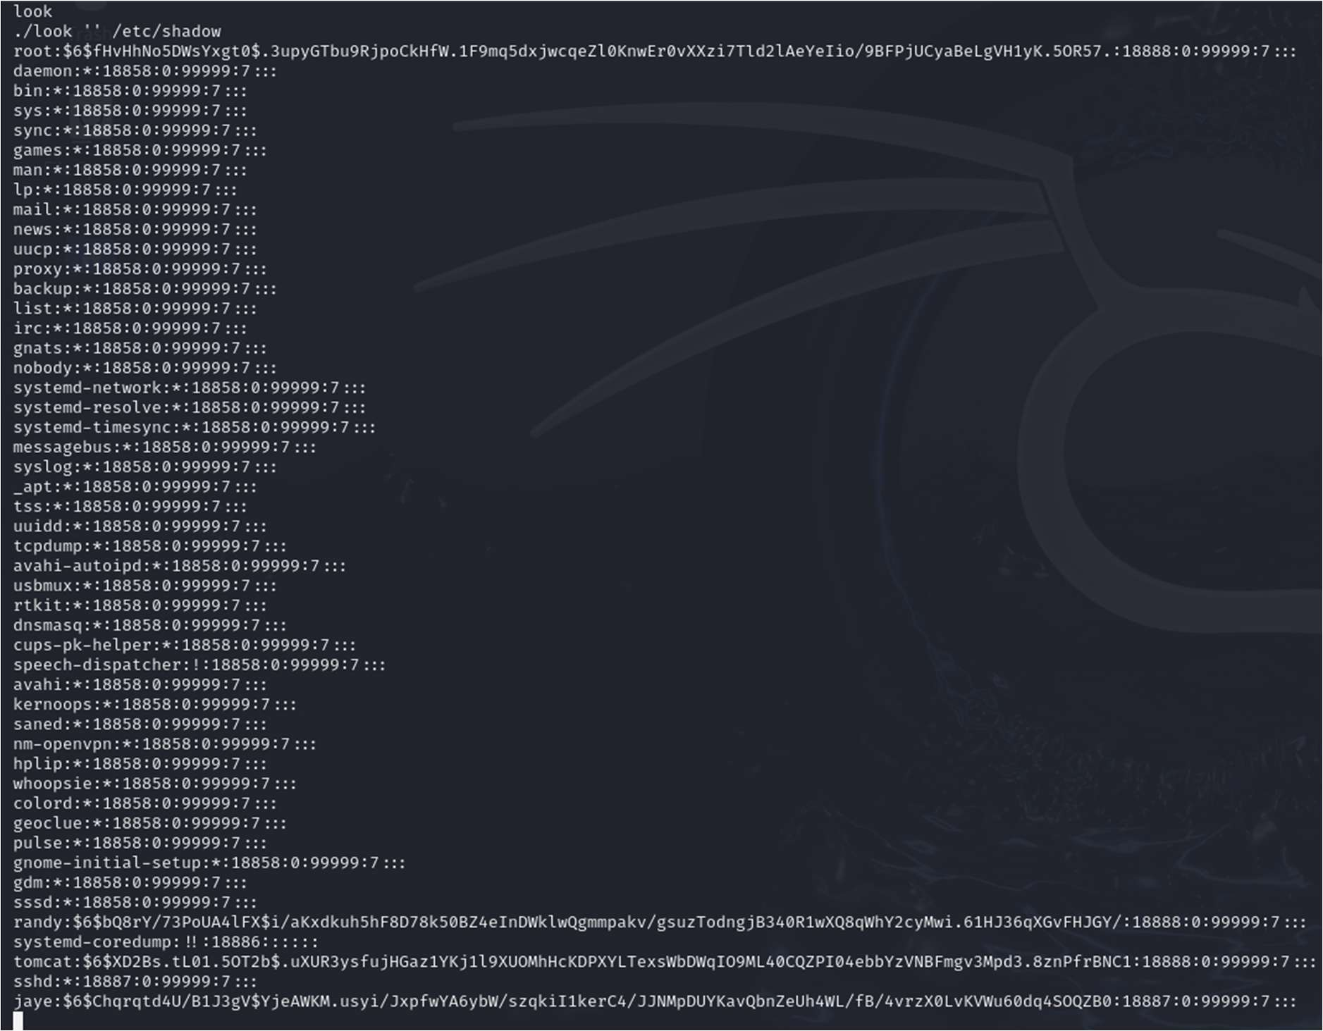

As a result, we use it to locate the /etc/shadow file. Boom!! We obtained the hash values of all users in this lab.

As you are aware, we already have the password for user Jaye. We copy user Randy’s hash value and save it in a file called hash.
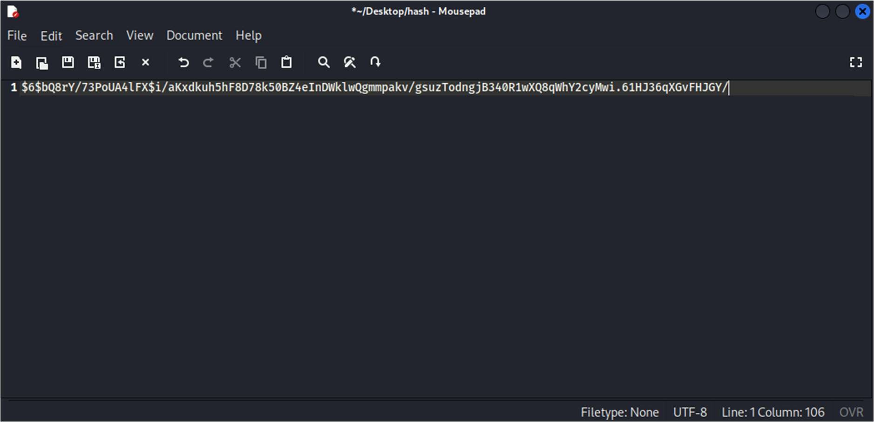

Using John The Ripper, we try to crack that hash.

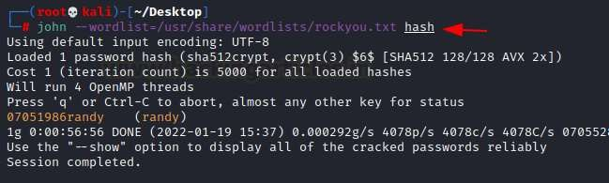
We cracked the password 07051986randy.

Now, we have all of the necessary information to begin privilege escalation. To login via ssh as user randy, we use the cracked password 07051986randy.
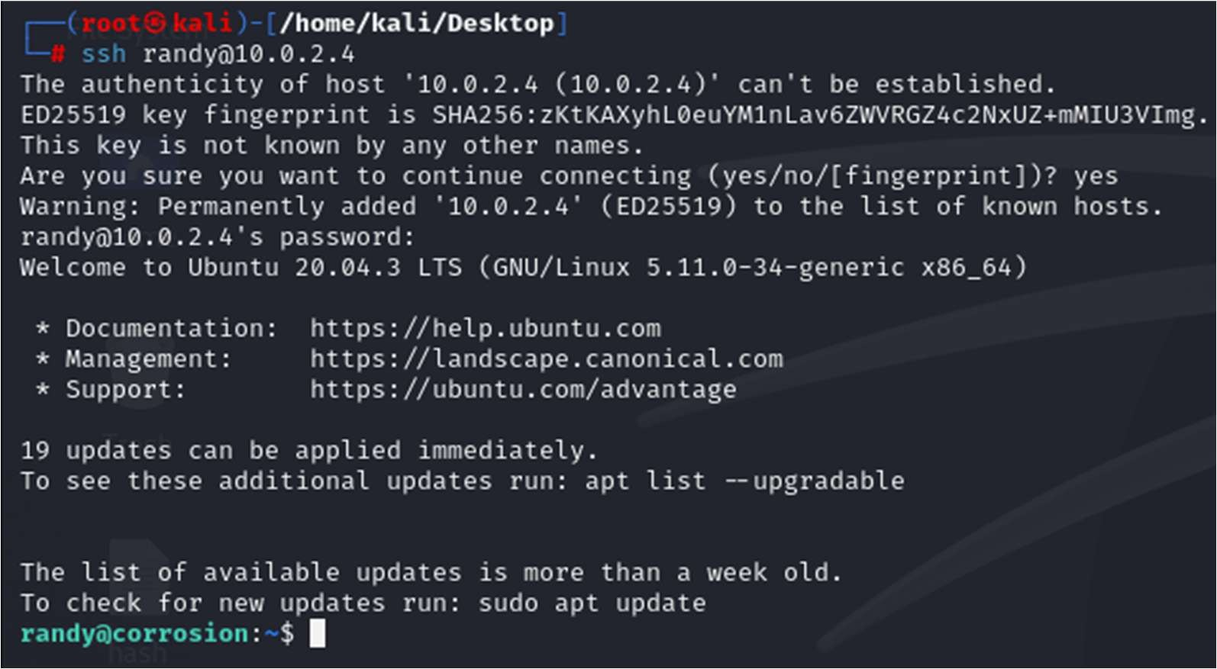
Then we used the (sudo -l) tool to examine this user’s limits.
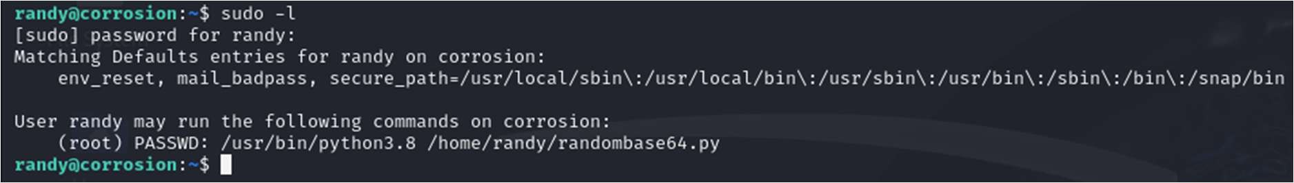

We discovered that it can be abused by python library hijacking.
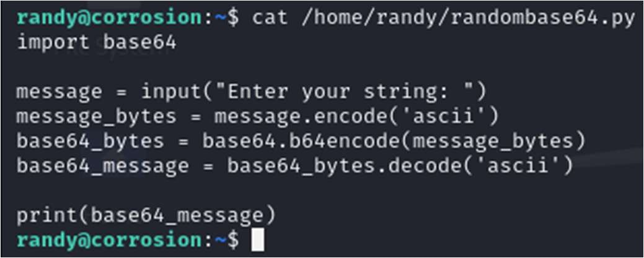
The randombase64.py python code can be used to perform this hijacking. which imports another file called base64.

To obtain base64 file coordinates, we use the locate command.
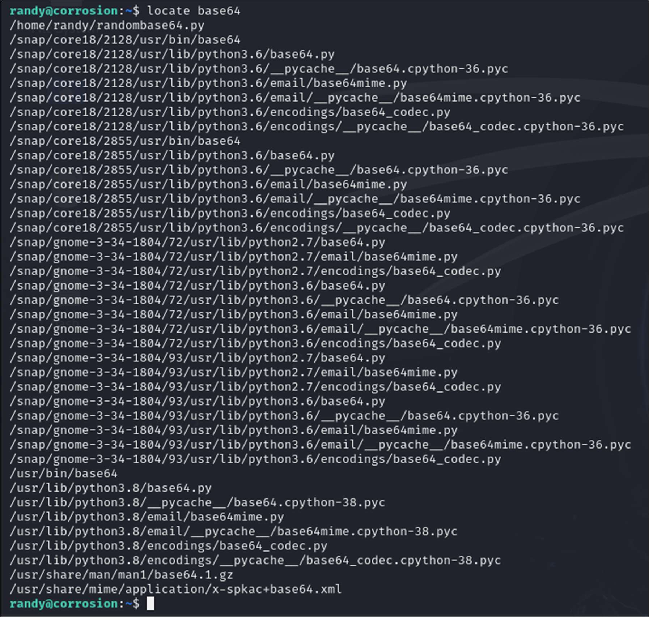
In a couple of seconds, we discover its coordinates. We investigated the file’s restrictions.
We made some changes to this base64 python file using the nano command.
Add this code to get root access to the victim’s machine.
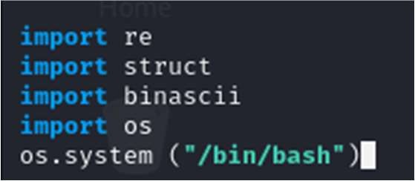

We are now coordinating the use of both Python files.
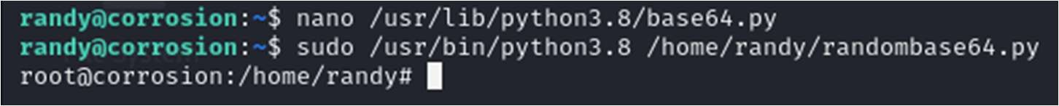
We obtained root access.

We immediately changed the directory to root and received the root flag.

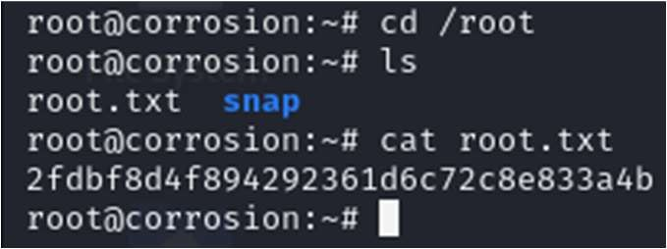

Review question:

- Which metasploit exploit have you used?
Tomcat Exploit

- How many users are found?
2 (jaye and randy)

- What’s their username and password?
Username: jaye Password: melehifokivai

Username: randy Password: 07051986randy

- Which password cracking mechanism has been used in this case?
John The Ripper

- Which library is used for privilege escalation?
Python OS library

